**Application Information Document - AID**

**MA’ADEN AMS Support**

**Oracle Applications : DBA**

Version : 1.0

**Application Information Document (AID)**

|  |
| --- |
|  |

Soft copy maintained in <Client> shared folder is the controlled master copy of this document. It is uncontrolled when printed or copied.

Repository Path: https://ibm.ent.box.com/folder/67986190670

**Authors**

|  |  |
| --- | --- |
| **Role** | **Name** |
| Oracle Apps DBA | Lisin E K, Tridibesh Roy |

**Reviewers**

|  |  |
| --- | --- |
| **Role** | **Name** |
| Senior Delivery Manager |  |
| Application Support Lead |  |

**Transition Manager**

|  |  |
| --- | --- |
| **Role** | **Name** |
| IBM Transition manager |  |
| Ma’aden Transition SPOC |  |

**Approver (s)**

|  |  |
| --- | --- |
| **Role** | **Name** |
| IBM SME |  |
| IBM Offshore DPE |  |
| Ma’aden Application SPOC |  |

**Revision History**

|  |  |  |  |
| --- | --- | --- | --- |
| **Version No.** | **Issue Date**  **(MM/DD/YY)** | **Description of changes** | **Location-Para/Page/Section** |
| **1.0** | 04-05-2019 | Initial Version |  |
|  |  |  |  |
|  |  |  |  |
|  |  |  |  |
|  |  |  |  |
|  |  |  |  |
|  |  |  |  |
|  |  |  |  |
|  |  |  |  |
|  |  |  |  |

**Distribution List**

|  |  |  |
| --- | --- | --- |
| **Name** | **Role** | **E-mail ID** |
| <Provide Group/Individual’s name> | <Doc owners’ role> | <Email id of the owner or group> |

**Table of Contents**

1. OBJECTIVES 7

2. Terminology and Acronyms 8

3. ORACLE EBS 9

3.1 EBS Architecture 9

3.2 EBS Structure With oracle Internet Users 10

3.3 Application and Database Platform (Oracle EBS) 10

3.4 Application Overview 11

3.4.1 DR Server 11

3.4.2 MWA Set Up 11

3.4.3 Printer Set Up 11

3.4.4 Workflow Configuration 11

3.4.5 Non-production Instances: 12

3.4.6 Other Applications/Database Details (Non-EBS Instances) 12

3.5 Integration/Interfaces 13

3.6 Backup and Recovery 15

3.6.1 Schema Backup 15

3.6.2 Application Backup 15

3.7 Patch Application 16

3.7.1 Localization Patches: 16

3.7.2 Patch Analysis/Testing: 17

3.8 Cloning Mechanism 17

3.9 Code Migration 19

3.10 User Management and Password Change Policy 20

3.10.1 Custom Users and Custom Tops: 20

3.10.2 Custom Managers: 20

3.10.3 User management: 20

3.10.4 Password Change Policy: 20

3.11 Daily Activities/Monitoring Tools/Cronjob scheduled 21

3.11.1 Scheduled Jobs 21

3.11.2 Tablespace alert/management: 21

3.12 Maintenance Activities 22

4.OBIEE/OBIA 23

4.1 OBIEE 11G Architecture 23

4.2 OBIEE 12C Architecture 24

4.3 Application Overview 24

4.3.1 OBIEE 12C Application Details 25

4.3.2 OBIEE 11G Application Details 27

4.3.3 DR Server 28

4.4 Integration/Interfaces 28

4.5 Backup and Recovery 28

4.6 Patch Application 29

4.7 Cloning Mechanism 29

4.8 Code Migration 29

4.9 User Management and Password Change Policy 29

4.10 Daily Activities/Monitoring Tools/Cronjob scheduled 29

4.10.1 Scheduled Jobs 30

4.10.2 Tablespace alert/management 30

4.11 Maintenance Activities 30

5. HYPERION 31

5.1 Architecture: 31

5.2 Application Overview 32

5.2.1 Hyperion Application Details: 32

5.2.2 DR server: 32

5.3 Backup and Recovery 33

5.3.1 Schema Backup 33

5.4 Patch Application 33

5.5 Cloning Mechanism 34

5.6 Code Migration 34

5.7 User Management and Password Change Policy 34

5.8 Daily Activities/Monitoring Tools/Cronjob scheduled 34

5.8.1 Scheduled Jobs: 34

5.9 Maintenance Activities 34

6. SOA Application 35

6.1 Architecture: 35

6.2 Application Overview 36

6.3 Integration Overview 36

6.4 Backup and Recovery 37

6.5 Patch Application 38

6.6 Code Migration 38

6.7 User Management and Password Change Policy 38

6.8 Daily Activities/Monitoring Tools/Cronjob scheduled 38

6.8.1 Scheduled Jobs 39

6.8.2 Tablespace alert/management 39

6.9 Maintenance Activities 39

6.10 Open/repetitive issues 39

7. OEM 40

7.1 Maintenance Activities 41

8. Ticket Management 42

# **1. OBJECTIVES**

The objective of the Application Information Document (AID) Is to provide members of the IBM Delivery team with an overview of the **Oracle Database and Applications**. The AID describes the function of the applications, the structure of the applications, the application configuration and the technical environment. This document will refer to any existing related documentation.

The AID will be used in conjunction with the Application Support Control Plan (ASCP) to support the application.

The IBM Delivery team will keep the AID throughout the life of supported applications.

# **2. Terminology and Acronyms**

Acronyms and terminology specifically used in this document are described below. Other acronyms commonly used can be found in the ASCP.

| **No** | **Terminology / Acronyms** | **Definition** |
| --- | --- | --- |
| 1 | AID | Application Information Document |
| 2 | ASCP | Application Support Control Plan |
| 3 | ERP | Enterprise Resource Planning |
| 4 | OBIEE | Oracle Business Intelligence Enterprise Edition |
| 5 | SOA | Service Oriented Architecture |
| 6 | OEM | Oracle Enterprise Manager |
| 7 |  |  |
| 8 |  |  |
| 9 |  |  |
| 10 |  |  |

# **3. ORACLE EBS**

## 3.1 EBS Architecture



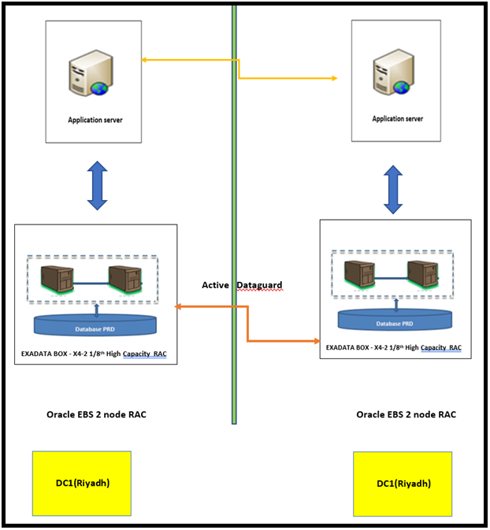 **Production Disaster Recovery**

## 3.2 EBS Structure With oracle Internet Users



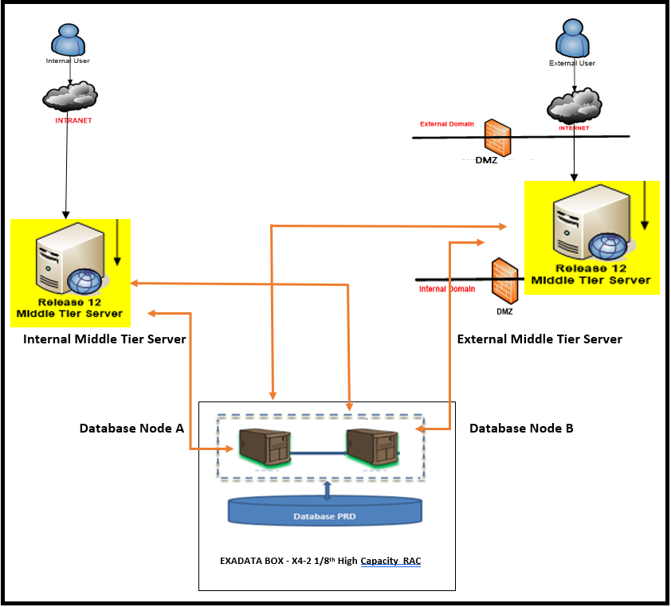

## 3.3 Application and Database Platform (Oracle EBS)

Red Hat Linux (5.5 to 6.8) and Oracle Linux OEL 6.8

## 3.4 Application Overview

Oracle E-Business Suite (EBS) is Enterprise Resource Planning software used for maintaining business applications for various processes.

* MA’ADEN EBS Application Running on R12.1.3 and database on 11.2.0.4.
* EBS Production is configured with 1 application node and 2 database RAC nodes in EXADATA box (X4-2 1/8th High Capacity RAC**)**. All the Application services like CM/Reports/forms etc are hosted on this single Application node only.
* All ERP application/servers are hosted in Riyadh datacentre (DC1).
* DMZ is configured for I-supplier modules on a separate box.
* ASM is enabled on Production and DR, no ASM on Non-production.

### 3.4.1 DR Server

* DR server has same configuration as PROD (2 node RAC in Exadata box).
* There is one Daily cloned instance which refreshed from DR instance.
* Active data guard is enabled in Production.

### 3.4.2 MWA Set Up

MWA is Mobile Web Applications.

* MWA is configured with EBS Prod and running on 3 ports.

### 3.4.3 Printer Set Up

* Printer configuration is IP based and will be configured as per user requirement.
* No separate tool/software configured to process the print requests.

### 3.4.4 Workflow Configuration

* Standard WF configuration is done.
* WF mailer services are kept down in non-prod instances.

### 3.4.5 Non-production Instances:

* There is one daily clone instance, DEV instance and there are 13 project instances.

|  |  |  |  |  |
| --- | --- | --- | --- | --- |
| **Sl.**  **No** | **Environment Title** | **URL** | **SID** | **Server Details** |
| 1 | Daily Clone (Non-RAC) | http://riysoaclone.maaden.com:8010/ | PCLONE | drdm01dbadm01 (10.50.43.4) |
| 2 | New Clone | http://riyoradev02.maaden.com:8070/OA_HTML/AppsLogin | TEST | riyoradev02.maaden.com |
| 3 | DEV Instance 1 | http://riyoradev03.maaden.com:8050 | TEST | riyoradev03.maaden.com |
| 4 | Patch Instance | http://riyoradev03.maaden.com:8070 | PATCH | riyoradev03.maaden.com |
| 5 | DEV Instance 2 | http://riyoramgbm.maaden.com:8060/ | IFRS | riyoramgbm.maaden.com |
| 6 | DEV Instance 3 | http://macoraotc02.maaden.com:8030/ | CLONE | macoraotc02.maaden.com |
| 7 | SIT | http://riyoramgbm02.maaden.com:8050/ | ONEBG2 | riyoramgbm02.maaden.com |
| 8 | Pre-Prod Instance | http://riysoaclone.maaden.com:8055 | CLONEDB | riysoa.maaden.com |
| 9 | EBS Upgrade Project | http://riymultitest01.maaden.com:8010 | ERPDBTST | riymultitest01.maaden.com |
| 10 | One BG Backup for Six Months and up to February 2019 | http://riyoracle03.maaden.com:8050 | VAT | riyoracle02.maaden.com |
| 11 | Emergency Needs | http://riyebsapps.maaden.com:8060/ | DCLONE | riyebsapps.maaden.com |

### 3.4.6 Other Applications/Database Details (Non-EBS Instances)

1. Audit DB – ACL
2. EHS DB (Environment, Health and Safety)

## 3.5 Integration/Interfaces

There are multiple integrations/interfaces in EBS. Applications/3rd Party tools are integrated through either DB links, SOA interfaces or using materialized views.

* Below is the list of integrations currently we have in EBS.

|  |  |  |
| --- | --- | --- |
| Sl.No. | Integration/Interface | Details |
| 1 | **HR Grievance** | This tool is integrated using Materialized Views (MV’s). MV’s refreshes automatically. no manual intervention needed unless any issues. |
| 2 | **I -Supplier – Share Point** | This is used for Ma’aden’s registration Process for suppliers and is integrated via Materialized Views. |
| 3 | **EFTM – (Equipment Fitness Task Management)** | This is Rex Tool to pull data from EBS and connected to DR via DB link. |
| 4 | **Pilog** | This is used for Master data Management and a Shared Folder is used to connect. It’s an EBS API. |
| 5 | **HSBC** | This is used for HSBC bank integration, where a finance process file is uploaded to the bank site and payment will happen. Shared Folder is mount on to the server for file uploads. |
| 6 | **B2B** | This is EBS – SOA integration for bank payments via SOA interface |
| 7 | **OTC-CASTHOUSE** | Order to Cash integration between EBS-SOA-MES. (For Cast house) |
| 8 | **OTC-ROLLING MILL** | Order to Cash integration between EBS-SOA-MES. (For Rolling Mill) |
| 9 | **OTC-Refinery** | Order to Cash integration between EBS-SOA-MES. (For Refinery Operation). |
| 10 | **OTM –EBS** | OTM is decommissioned hence this interface is not active. |
| 11 | **Viziya** | This is Asset Maintenance & Management Software. A user is created in EBS and Viziya is directly connected to EBS through this user for scheduling. |
| 12 | **Aventex** | This is used for document printing in EBS(especially Work Orders and Procedural documents). We may encounter printing/printer related issues, need to co-ordinate with functional team to resolve. If not resolved, we can connect with vendor (STR software) for help. |
| 13 | **I-Supplier/I-Sourcing** | This is connected through to EBS application through DMZ Node. |
| 14 | **I-Recruitment** | This has been decommissioned and not in use anymore. |
| 15 | **Taleo Cloud LMS** | This tool is Leave Management System and is integrated with EBS through SFTP.File from EBS is sent to DMZ server and from there it’s sent to Taleo. |
| 16 | **HR KPI** | This is integrated via Materialized View and data is fetched from EBS to HR KPI Dashboard for Management. |
| 17 | **WMS Scanner Guns** | This is used for Shipping and is integrated with WMS Ports. |
| 18 | **MY Ma’aden** | This is a service Portal for Ma’aden Employees. This is integrated using DB link. Data is fetched from EBS to MS SQL DB via DB link and from there to MS Share Point. |
| 19 | **Annual Declaration** | Related to Compliance. Employee details are fetched from EBS through DB link to compliance portal. |
| 20 | **MA Attendance** | This is Ma’aden Aluminium Attendance Portal connected to EBS through DB link. Related is HR and POC is Mohammed Ishthiyaq. |
| 21 | **MA MOC** | This is LOBA application integrated with EBS via DB link. |
| 22 | **Clinic Application** | This related to the Clinic Portal for employees using clinical services of ma’aden in the Plant sites. Integrated with EBS via DB link. |
| 23 | **LTV Application** | No info as of now in regard to this, integrated with EBS via DB Link. |
| 24 | **Panalpina Interface** | Panalpina is 3rd Party vendor of Ma’aden which takes care of the Shipments/Freight Forwarding and process the PO’s on behalf of Ma’aden. This is integrated with EBS via SFTP file. PO’s and Shipment file is prepared and pushed to Panalpina via SFTP and once they receive the file will process the orders accordingly. |
| 25 | **MA Cast House** | This is also for ALCOA integration through SFTP file. |
| 26 | **VAT Implementation** | This is VAT integration with EBS. |
| 27 | **Ma’aden Talent Acquisition** | Ma’aden’s Recruitment Portal for Job postings. |
| 28 | **Offline Shipping** | This integration is used for Offline shipping when SOA is down for more than 2 hours then shipments/transactions are captured in SQL DB server via DB link from EBS. Once the SOA is up the transactions are synced/Fetched from MS DB server to EBS and SOA. |
| 29 | **Quintiq Integration** | This is planning Application used for Process Manufacturing. Interfaced with EBS via SOA interface (EBS – SOA – Quintiq**).** |

## 3.6 Backup and Recovery

* Database full back up as well as archive log backup is done using veritas net backup.
* System admin team is responsible for taking veritas back up.
* DBA Responsibility is to provide script, schedule, frequency and check DB related backup issues.
* Backup is directly taken on tape. No local backup is taken. Tape retention policy for backup is taken care by Veritas (System Administrator) team.
* Tape backup is tested once/twice per quarter.
* DBA team checks RMAN logs for successful completion. System admin also send reports every day to DBA with status of backups.
* Backup schedule for different DB’s are between 9PM – 11PM KSA Time.
* Daily Backup of EBS take approx. 3 – 4 hrs.
* Full Back up (L0 backup) is scheduled to run every day.
* Offline backup is taken on adhoc basis as per requirement.
* Archive log backup is taken separately for EBS Database and It is taken along with db backup for other Databases.

### 3.6.1 Schema Backup

* No explicit Schema export/import is scheduled.
* Schema Export/Import is taken manually on adhoc basis as per user/business requirement.

### 3.6.2 Application Backup

* Application filesystem are copied to DR server every night.

## 3.7 Patch Application

**Patch Request**

**Regular Support Project Based Support**

Patch Request Usually comes from Regular Support and Project based support.

**Project Based Support:**

* Project based is the requirement by project team.
* patch is applied to UAT or SIT instances before moving to Production

**Regular Support**:

* In case of regular support requests, first patch is applied to daily cloned instance. once it is validated by business it will be taken to production.

Change management process is followed for applying patch in production instance. Downtime communication is sent by certain team once change request for patching is approved.

|  |  |  |
| --- | --- | --- |
| Sl.No. | Database Patch | Application Patch |
| 1. | Database patch is applied quarterly as part of cpu and psu (N-1). | Application Patches(adpatch) are applied on demand through change management process. |
| 2. | No Downtime Required. | Downtime Required. |
| 3. | Patch Location - | Patch Location - |

For any critical patch’s emergency downtime can be taken with proper approvals.

### 3.7.1 Localization Patches:

* Sometimes localization patches (AR localization patches) also need to apply.
* 99% of users using English only but Arabic also installed.

### 3.7.2 Patch Analysis/Testing:

* There is no patch analysis tool.
* Testing impact analysis will be done by patch requestor/initiator.
* There is no patch inventory

## 3.8 Cloning Mechanism

**Cloning**

**Automated** **Manual**

Cloning is performed in 2 ways. That is manual and automated.

**Automated Cloning:**

* Cloning is automated on daily clone instance.
* Daily Clone is done using duplicate backup.
* It has one db node and 1 application node. It is refreshed from DR instance.
* Cron job is scheduled for daily refresh and is running every night.
* Time taken for daily clone instance refresh is 2.5 – 3 hrs. (DB clone takes approx. 2 hrs and Application clone 1 hr).
* Data masking script is embedded in the post cloning script for daily cloned instance.
* Perform Health check every day on cloned instance.

**Manual Cloning:**

* Apart from Daily cloned instance rest of the non-PRD instances are refreshed manually.
* Manual clone frequency is based on user/project requirement.
* Manual Clone takes around 3 days.
* Need to take Instance owner (Stake Holders)/Application Manager Approval before bringing down the instance for clone.
* Data masking is done on all non-PRD instances before handling the instance to the users.

**User Access to Cloned Instance:**

* By default, all the users (Business Users) have access to the cloned instance. But the instance details are not shared to all unless requested.
* Access is given to specific users upon request.
* All the support team gets the access to cloned instance.
* As part of the post clone steps user access script is ran in which the support team access details are added.
* E-mail Scrambling is not done as a part of post clone steps.

**Repetitive Issues on Cloning:**

Cloning process is pretty much standard and no specific repeating issues.

## 3.9 Code Migration

* Code migration in production is carried out through change management process in service now tool.
* There is no version control tool used for migration, code is attached to change request itself.
* DBA need to verify all the approval from the change request which is assigned for final migration to prod. DBA will go for execution only if CR has all approval in place.
* 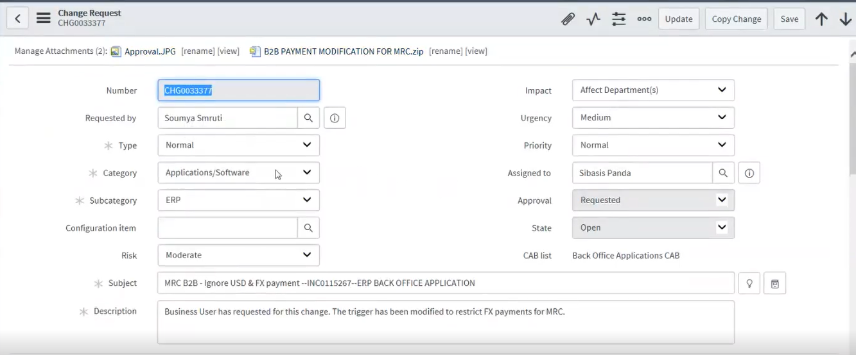Verify all the proof of non-prod execution is attached to CR before migrating to prod instance.

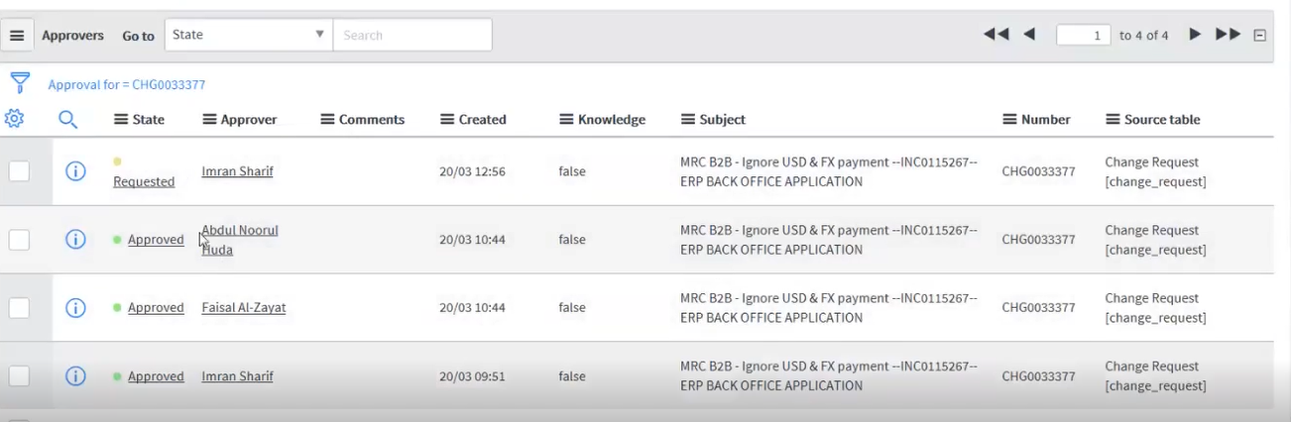

## 3.10 User Management and Password Change Policy

### 3.10.1 Custom Users and Custom Tops:

* There are around 7 -8 Custom Users in Oracle EBS (ex: XXMPC, XXMA, XXMW.etc). As per the Custom users there are also 7 -8 Custom Tops.
* Custom Users have all the basic roles/privileges and other specific roles as per requirement.
* Each custom schema has custom tablespace.
* Apart from Standard Oracle Application users (Like Sysadmin and Individual Login’s) there are some custom front end users (For Support Team) to schedule Concurrent Jobs.

### 3.10.2 Custom Managers:

* There are few custom managers to process certain requests. Custom managers process Long Running jobs and Month End Payroll Jobs.

### 3.10.3 User management:

* Front End User Management is automated.
* When a new employee joins, the HR team creates Emp id and in turn creates an Oracle user id with self Service responsibility. User then logs into the oracle and requests for a particular responsibility which when approved automatically responsibility gets assigned.
* DB user creation, Change Request is followed.

### 3.10.4 Password Change Policy:

* Passwords of Front-End Application users/FND user are set to 90 days expiration and is reset with FNDCPASS.
* Apart from “apps” password every other DB user password is reset after 90 Days.
* Sysadmin user password is changed every quarter.
* Exadata DB user’s password also changed quarterly.
* Some DB users are set to 90 days expiration and some are set to unlimited.

DBA have direct root access and sudo access as well on linux servers. Palladian tool is used to audit the DBA’s login to the Linux Servers.

## 3.11 Daily Activities/Monitoring Tools/Cronjob scheduled

* OEM is configured with all DB servers for monitoring purpose. Application server is monitored manually (mountpoint and resource utilization).
* **/tmp** of application needs to be monitored as it sometimes fills up fast.
* Daily Health check is performed and need to send health check report to dba lead (Muhammed Ali) including all dba members.
* There is no separate check list for the month/Quarter end. Daily health check list is monitored 2-3 times a day during month end closure.
* DB audit is enabled.

Daily Health check report template: -

### 3.11.1 Scheduled Jobs

* Most of the jobs are scheduled from OEM.
* Cron jobs are setup to delete logs/temp files for DB and application.
* In addition to that there is one cronjob in DB server for monitoring tablespace usage.
* Concurrent log/out files also deleted from application as Cron job is scheduled for it (60 days retention).
* GSS for ALL is scheduled to run Weekly (Every Friday Night).
* Standard WF purge program is scheduled for WF purging.
* Standard EBS purge program are scheduled as per business requirement.

### 3.11.2 Tablespace alert/management:

* Tablespace usage is monitored through scheduled cronjob/OEM alert and it triggers mail alert whenever usage reaches threshold of 85%.
* Datafiles of 5 or 10GB added with ‘auto extend on’ up to 32GB.

## 3.12 Maintenance Activities

* Preventive Maintenance schedule is generally done once per month tentatively on 2nd or 3rd weekend.
* DR drill happens every quarter.
* DR drill process, First CHG request is raised, once approved by the CAB/Business take downtime of the corresponding application and its integrated applications and start the activity.
* Downtime for DR testing activity is 3 hours.
* Maintenance activities include adhoc WF bounce on adhoc basis when we see issues with WF.
* Apache is bounced is the system is slow upon approval from business.

# **4.OBIEE/OBIA**

## 4.1 OBIEE 11G Architecture



## 4.2 OBIEE 12C Architecture



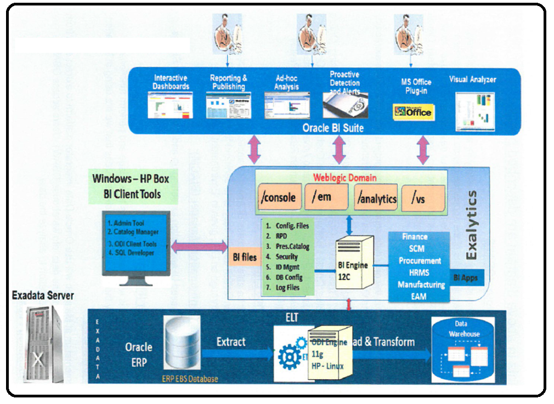

## 4.3 Application Overview

OBIEE is a Business Intelligence tool by oracle corporation. Its proven architecture and common infrastructure producing and delivering enterprise reports, scorecards, dashboards, ad-hoc analysis, and OLAP analysis provides a rich end-user experience.

* MA’ADEN OBIEE is running on 2 version of instances -11g already running and 12c also partially implemented now.
* OBIEE Production database is on Exadata server (2 node RAC), Application is running on Exalytics box and client is on windows server.
* BI 11g non-prod instance are exact replica of production and they are in DR Exadata server. 12c non-prod instances are running on HP server.
* 12c database size is 1.5 to 1.8 TB and 11g db size around 900 GB
* Database growth for 11g database is 70 to 80 GB quarterly and yearly it is 200 to 300GB. 12c database growth is not captured yet.
* There is no encryption or data masking in BI side.

### 4.3.1 OBIEE 12C Application Details

|  |  |  |  |
| --- | --- | --- | --- |
| **Application Name** | **Server Name** | **Server Details** | **Description** |
| **OBIEE 12C** | Database | dm01-scan | OBIEE 12C Production |
| OBIA 11g Application | Exalytics |
| OBIEE 12C Application | DC1-OBIA-V-01-T (172.17.11.134) |
| Database | DC1-OBIA-P-01 (172.17.1.94) | OBIEE 12C DEV |
| OBIA 11g Application | riyhypdevl01 (172.17.1.93) |
| OBIEE 12C Application | dc1-obia-v-02(172.17.11.170) |
| Database | DC1-OBIA-P-02-T (172.17.1.156) | OBIEE 12C TEST |
| OBIA 11g Application | DC1-OBIA-P-01-T (172.17.1.62) |
| OBIEE 12C Application | riyhypdevl01 (172.17.1.93) |

**URLs:**

|  |  |  |  |
| --- | --- | --- | --- |
| **Application** | | **URL** | **Description** |
| OBIA 11G | WebLogic Server | http://exly.maaden.com:7041/console | OBIEE 12C Production |
| FMW Control | http://exly.maaden.com:7041/em |
| BI Analytics | http://exly.maaden.com:9784/analytics |
| BI Apps CM | http://exly.maaden.com:9784/biacm |
| ODI Console | http://exly.maaden.com:15061/odiconsole |
| OBIEE 12C | WebLogic Server | http://DC1-OBIA-V-01-T.maaden.com:7001/console |
| FMW Control | http://DC1-OBIA-V-01-T.maaden.com:7001/em |
| BI Analytics | http://DC1-OBIA-V-01-T.maaden.com:7003/analytics |
| BI Apps CM | http://DC1-OBIA-V-01-T.maaden.com:7003/xmlpserver |
| OBIA 11G | WebLogic Server | http://riyhypdevl01.maaden.com:7001/console | OBIEE 12C DEV |
| FMW Control | http://riyhypdevl01.maaden.com:7001/em |
| BI Analytics | http://riyhypdevl01.maaden.com:9704/analytics |
| BI Apps CM | http://riyhypdevl01.maaden.com:9704/biacm |
| ODI Console | http://riyhypdevl01.maaden.com:15001/odiconsole |
| OBIEE 12C | WebLogic Server | http://dc1-obia-v-02.maaden.com:7001/console |
| FMW Control | http://dc1-obia-v-02.maaden.com:7001/em |
| BI Analytics | http://dc1-obia-v-02.maaden.com:7003/analytics |
| BI Apps CM | http://dc1-obia-v-02.maaden.com:7003/xmlpserver |
| OBIA 11G | WebLogic Server | http://DC1-OBIA-P-01-T.maaden.com:7001/console | OBIEE 12C TEST |
| FMW Control | http://DC1-OBIA-P-01-T.maaden.com:7001/em |
| BI Analytics | http://DC1-OBIA-P-01-T.maaden.com:9704/analytics |
| BI Apps CM | http://DC1-OBIA-P-01-T.maaden.com:9704/biacm |
| ODI Console | http://DC1-OBIA-P-01-T.maaden.com:15001/odiconsole |
| OBIEE 12C | WebLogic Server | http://riyhypdevl01.maaden.com:7101/console |
| FMW Control | http://riyhypdevl01.maaden.com:7101/em |
| BI Analytics | http://riyhypdevl01.maaden.com:7103/analytics |
| BI Apps CM | http://riyhypdevl01.maaden.com:7103/xmlpserver |

### 4.3.2 OBIEE 11G Application Details

|  |  |  |  |
| --- | --- | --- | --- |
| **Application Name** | **Server Name** | **Server Details** | **Description** |
| OBIEE 11G | Database |  | UAT Instance |
| OBIEE 11G application | exly (172.17.17.26) |
| Informatica | riyobitest.maaden.com(172.17.1.163) - OLE - 5.11 x86_64 |
| Client Tool | dc1-hype-v-04-u(172.17.11.142) - windows 2008 |
| Database |  | TEST Instance |
| OBIEE 11G application | exly (172.17.17.26) |
| Informatica | riyobitest.maaden.com(172.17.1.163) - OLE - 5.11 x86_64 |
| Client Tool | DC1-HYPE-V-03-T(172.17.11.141) - Windows 2008 |
| Database |  | Production Instance |
| OBIEE 11G application | Exly - 172.17.17.26 |
| Informatica | RIYOBIPROD01.maaden.com - 172.17.1.166 |
| Client Tool | DC1-HYPE-V-02-D - 172.17.11.115 - windows |
| DAC | RIYOBIPROD01.maaden.com - 172.17.1.166 |

**URLs:**

|  |  |  |  |
| --- | --- | --- | --- |
| **Application** | | **URL** | **Description** |
| OBIEE | WebLogic Console | http://exly.maaden.com:8031/console | UAT Instance |
| Oracle Enterprise Manager | http://exly.maaden.com:8031/em |
| Business Intelligence Enterprise Edition | http://exly.maaden.com:9734/analytics |
| Business Intelligence Publisher | http://exly.maaden.com:9734/xmlpserver |
| Real-Time Decisions | http://exly.maaden.com:9734/ui |
| Calculation Manager | http://exly.maaden.com:9734/workspace |
| Financial Reports | http://exly.maaden.com:9734/workspace |
| Workspace | http://exly.maaden.com:9734/workspace |
| Essbase Suite APS | http://exly.maaden.com:9734/aps |
| Informatica |  |  |
|  |  |
| DAC |  |  |
|  |  |
| OBIEE | WebLogic Console | http://exly.maaden.com:8021/console | TEST INSATNACE |
|  | Oracle Enterprise Manager | http://exly.maaden.com:8021/em |
|  | Business Intelligence Enterprise Edition | http://exly.maaden.com:9724/analytics |
|  | Business Intelligence Publisher | http://exly.maaden.com:9724/xmlpserver |
|  | Real-Time Decisions | http://exly.maaden.com:9724/ui |
|  | Calculation Manager | http://exly.maaden.com:9724/workspace |
|  | Financial Reports | http://exly.maaden.com:9724/workspace |
|  | Workspace | http://exly.maaden.com:9724/workspace |
|  | Essbase Suite APS | http://exly.maaden.com:9724/aps |
| Informatica |  |  |
|  |  |
| DAC |  |  |
|  |  |

### 4.3.3 DR Server

* No DR instances Running for BI applications.

## 4.4 Integration/Interfaces

* There is no third-party integration.

## 4.5 Backup and Recovery

* OBIEE 11g backup is scheduled daily basis from Exadata server and for 12c it is taken weekly basis, currently running from HP server.
* cronjob is scheduled for taking filesystem (some specific files) backup.
* Application backup is scheduled on crontab and is taking daily basis. Manual backup is also taken on adhoc basis.
* BI application backup and recovery is not that much easy process. It’s better to go for re-installation or re-configuration.

## 4.6 Patch Application

**Database Patch**

* DBA take care of database patches and applies quarterly.

**Application Patch**

* Application team will take care of application patches (like java patches).
* DBA will take backup before applying patches.
* change management process is followed.

## 4.7 Cloning Mechanism

* For BI application there is no cloning, new installation is preferred.

## 4.8 Code Migration

* Code migration is taken care by application team. DBA will support them if required.

## 4.9 User Management and Password Change Policy

* Database user creation is managed through change management process.
* DBA responsibility is only to change password in the database side as well as OS level password. Application team is responsible for changing password in application side.
* Role and responsibilities are managed by application team only.
* Application team take care of application access. Paladion tool is configured with Exadata server to audit user login.

## 4.10 Daily Activities/Monitoring Tools/Cronjob scheduled

* Application daily health check is done by application team and for database dba perform standard health checks (alert log, table space, OEM alert, instance status etc.).
* There is no tool used for Application monitoring. Application monitoring comes under the responsibilities of Application Team. Database server is monitored through OEM.
* Server filesystem is being monitored daily basis as part of daily health check.
* DB alert log/trace file will be purged if there is huge growth.
* Purging alert log and archive log files. In the backup script itself archive log purging is scheduled with sysdate-1.
* DBA need to be more cautious whenever they run full load. Huge archive generation occurs during this time.
* Performance related issue occurs only when data loading is there.
* There is no Regular activity related to index. If there are any performance issues, then only need to check index and rebuild if required.
* One Data Centre visit will be done to show DBA actionable.
* CPU and memory utilization are normal in exalytics box. No issues in performance and all good in application side as well.

### 4.10.1 Scheduled Jobs

* One cronjob is scheduled to delete some core dump files to fix mount point issues in application server. Another cronjob is for taking filesystem (some specific files) backup.
* Application backup is scheduled on crontab and is taking daily basis

### 4.10.2 Tablespace alert/management

* Datafile is added when tablespace usage crosses threshold of 85%.
* Datafiles of 5 or 10GB added with ‘auto extend on’ up to 32GB.

## 4.11 Maintenance Activities

* Maintenance activities are adhoc based and dba takes care of DB and server related steps, application part is taken care by application team.
* Downtime for application is taken care by application team and it is through change management process.
* Application bounce is taken care by application team and dba take care only database bounce. If any issue with application bounce, dba need to kill OS level process if required.

# **5. HYPERION**

## 5.1 Architecture:

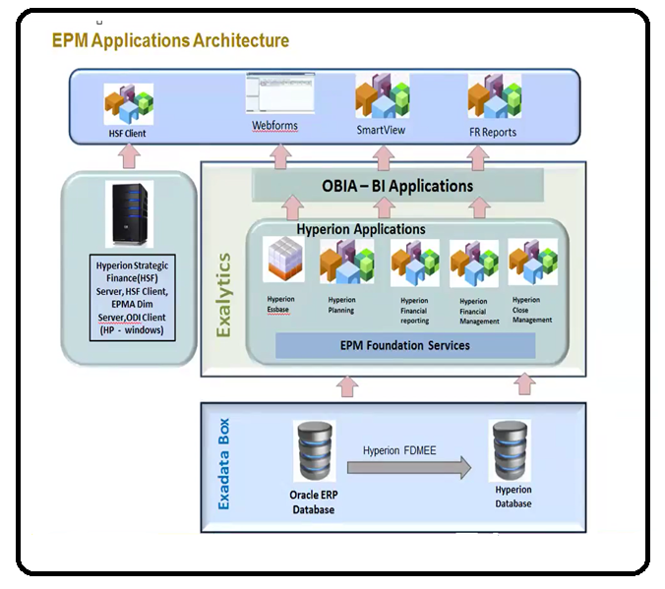

## 5.2 Application Overview

Hyperion is a highly effective financial and planning as well as Enterprise Performance Management (EPM) Tool.

* MA’ADEN Hyperion Have 2 databases – FDM and EPM
* FDM is to store mapping related metadata and EPM stores original data for reports and all.
* There are 3 instances. PROD, UAT and DEV. Production is in Exadata box and non-prod instances are in DR Exadata server. All the corresponding applications are running on Exalytics box. Client is on hp windows machine and It is controlled by sysadmin team.
* We have only one Exalytics box. All prod and non-prod applications are running on this server.
* Production is residing in Exadata server. Applications is running on Exalytics box.
* Database size is not too huge .100 to 150GB size only. growth is around 100Gb yearly.
* There is no Hyperion printer set up.

### 5.2.1 Hyperion Application Details:

|  |  |  |  |
| --- | --- | --- | --- |
| **Application Name** | **Server Name** | **Server Details** | **Description** |
| HYPERION | Database |  | UAT Instance |
| Hyperion application | Exly.Maaden.Com (172.17.17.26) - Exalytics OEL 5.8 |
| Client Tool | DC1-HYPE-V-04-U (172.17.11.141) - HP Windows 2008, 64Bit |
| Database |  | TEST Instance |
| Hyperion application | Exly.Maaden.Com(172.17.17.26) - Exalytics OEL 5.8 |
| Client Tool | DC1-HYPE-V-03-T (172.17.11.141) - HP Windows 2008, 64Bit |

### 5.2.2 DR server:

* DR is not available for Hyperion.

## 5.3 Backup and Recovery

* Database backup is on regular basis.
* Application backup is based on adhoc basis and it is taken once application is shutdown.
* One Cron job is set to take some important application files mentioned by Application team.

### 5.3.1 Schema Backup

* Schema backup request comes sometimes from application team
* Export schema or table is taken as per requirement.

## 5.4 Patch Application

Hyperion Patching process is same as BI Application.

**DB Patch:**

* DBA take care of db patches and applies quarterly.
* Patch Top is there for DB patches.

**Application Patch:**

* Application team will take care of application patches.
* Hyperion team’s scope is to stop/start Hyperion services and perform checks post patching.
* Test instance is patched first, then tested. usually this happens on Tuesday, Wed.
* Production Patching is done on Fri/Sat.
* Communications need to be sent to users before any maintenance activities.
* Hyperion patches to be installed by Hyperion AMS team as and when required.

## 5.5 Cloning Mechanism

* Database clone has not been done yet. It is standard process.
* Application clone is taken care by application team.

## 5.6 Code Migration

* Code migration is taken care by application team. DBA will support them if required.

## 5.7 User Management and Password Change Policy

* DBA responsibility is only to change password in the database side as well as OS level password.
* Application team is responsible for changing password in application side.
* DB/OS User creation is managed through CR process and application user creation is taken care by application team.
* Role and responsibilities are managed by application team only.
* Paladion tool is configured with Exadata server to audit user login.

## 5.8 Daily Activities/Monitoring Tools/Cronjob scheduled

* Application daily health check is done by application team and for database dba perform standard health checks (alert log, table space, OEM alert, instance status etc.).
* DB alert log/trace file will be purged if there is huge growth.
* There is no encryption or data masking in Hyperion.
* There are no open issues.

### 5.8.1 Scheduled Jobs:

* One Cron job is set to take some important application files mentioned by Application team.

## 5.9 Maintenance Activities

* Database and server part are taken care by DBA and Application part is handled by Hyperion application team.
* Application bounce is taken care by application team and dba take care only database bounce.

# **6. SOA Application**

## 6.1 Architecture:

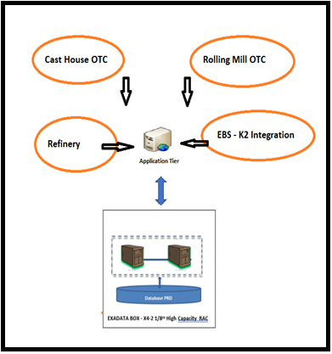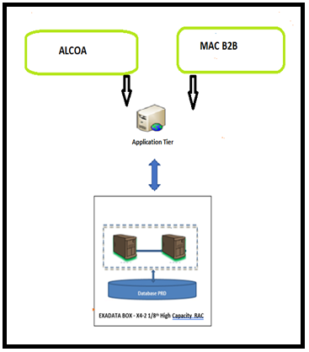

**Intranet Domains Over the Internet**

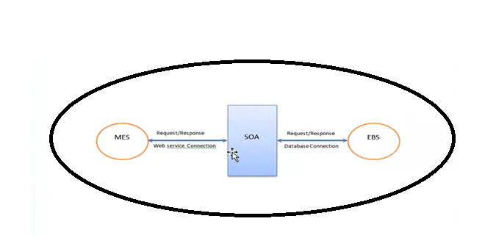

**Refinery**

**MES – SOA - EBS**

## 6.2 Application Overview

Oracle SOA Stands for Oracle Service-Oriented Architecture. Oracle SOA makes it easy to rapidly assemble services into modular and flexible business applications.

* MA’ADEN SOA Version is 11.1.1.7.3 and Database Version is 11.2.0.4.
* There are 2 SOA Instances that are being used and each SOA instance has its own DB.
* 1 SOA Application for internal interfaces (Integration) and 1 SOA instance for external interfaces like B2B.
* Each SOA instance has 1 Application Node only.
* Both the SOA instances Databases are on Exadata 2 Node RAC.
* There is no High Availability for Application Nodes.
* Database DR is Available.

## 6.3 Integration Overview

* There are 6 Domains in SOA. 4 Intranet Domains (in-house) and 2 Internet Domains (B2B).
* Below are the SOA Integrations in Ma’aden.

Intranet Domain -

1. Cast House OTC (EBS MES)
2. Rolling Mill OTC (EBS MES)
3. Refinery (EBS-MES)
4. EBS-K2 Integration (EBS-k2)

Over the Internet -

1. MAC B2B
2. ALCOA Integration
3. K2 Integration

* Below Table depicts the integrations and their targets along with the integration technology being used.

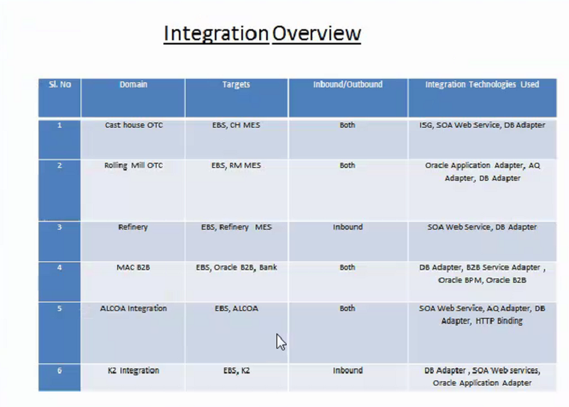

## 6.4 Backup and Recovery

* DB backup is scheduled daily through Cron.
* Application backup will be taken on adhoc basis whenever required and before applying any application level patches.
* Backup of important files will be taken as and when needed upon request of application team before migration of any JAR files. Etc.

## 6.5 Patch Application

DBA Take care of DB patch and Application Patch as well.

**Database Patch:**

* DB Patches are applied as part of Quarterly CPU Patching cycle.

**Application Patch:**

* Application Patching is taken care by DBA Team.
* Application backup is taken manually before application of patches.
* Application Patches needed to be applied on all the 6 Domains irrespective of patch intended for a particular module or domain.
* There is only one non-PRD SOA instance and patches that are requested from Application team are applied in non-PRD and tested properly by SOA team and upon their conformation and CR process will apply the Patch to SOA PRD.
* Mount Point backup is taken before applying patches.

## 6.6 Code Migration

* Code migration is taken care by application team. DBA will support them if required.

## 6.7 User Management and Password Change Policy

* All the integration is done through weblogic user only and no other users are there.
* Database user creation is managed through change management process.
* Application password is not changed till now, it will be changed upon request from Application team.

## 6.8 Daily Activities/Monitoring Tools/Cronjob scheduled

* Daily Activities of SOA Applications include to check all the domain services and the managed, admin services are up and running without issues.
* DB is monitored through OEM.
* Application monitoring is done manually like log file monitoring and mount point monitoring.
* There is no Regular activity related index. If there is any performance issues then only need to check index and rebuild if required.
* DB alert log/trace file will be purged if there is huge growth.
* Application Log files we need to check manually if growth is high we need to clear them no cron job is scheduled for this.
* Purging is done in SOA. Application team will share the purge script every month and DBA team executes that.
* 3 Months retention period is used in SOA for Purging.

### 6.8.1 Scheduled Jobs

* DB backup is scheduled daily through Cron.
* No Cron jobs are set for SOA application server.

### 6.8.2 Tablespace alert/management

* Datafile is added when tablespace usage crosses threshold of 85%.
* Datafiles of 5 or 10GB added with ‘auto extend on’ up to 32GB.

## 6.9 Maintenance Activities

* SOA PRD full bounce is carried out as part of the monthly maintenance activity along with EBS Maintenance.
* Apart from the monthly Maintenance if there is any issue with any particular domain or issues with application performance will bounce upon taking approval from Application Manager.
* There are no explicit year End Activities for SOA just need to do regular health/sanity checks.
* We need to align application team when there is outage window for maintenance of Non-PRD instance.
* For JVM issue we will bounce the required Domain service.

## 6.10 Open/repetitive issues

* Connectivity issues for MAC-B2B integration and JVM Heap Size issues.

# **7. OEM**

Oracle Enterprise Manager (OEM or EM) is a set of web-based tools aimed at managing software and hardware produced by Oracle Corporation as well as by some non-Oracle entities.

MA’ADEN is using OEM for database monitoring purpose and all alert is set up in the OEM which will be triggering to mail as per threshold values.

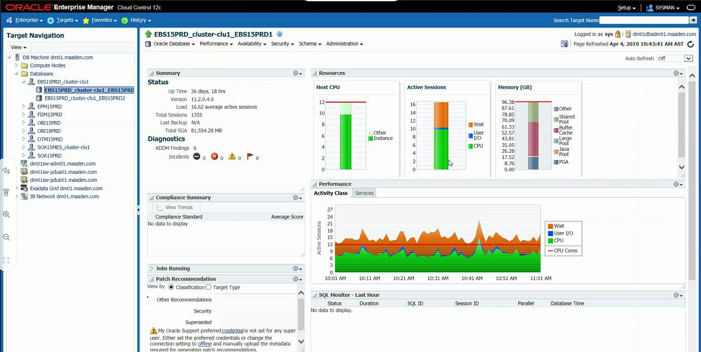

* OEM Version being used is OEM 12c Release 5.
* OEM is configured for Production and DR boxes. Non-prod instances are not being monitored through OEM.
* For all event occurring, warning and critical alerts have been set up and will be triggering to mail as per threshold values.
* There is no activity (patching, password change etc.) performed from OEM apart from monitoring and alert set up.
* DBA use sysman access for OEM.
* Resource Utilizations alerts have been set up in OEM but there is no report generating from OEM on regular basis.
* OEM and RMAN catalog instances are residing in hp box.

## 7.1 Maintenance Activities

* Apart from monthly maintenance activities OEM is bounced on adhoch basis. If there is any issue with OEM, then only go for OEM bounce.
* Before performing any maintenance activities to prod instances black out is set up in OEM.

# **8. Ticket Management**

MA’ADEN is using Service Now Tool for managing Tickets.

Group Name – ERP MGS

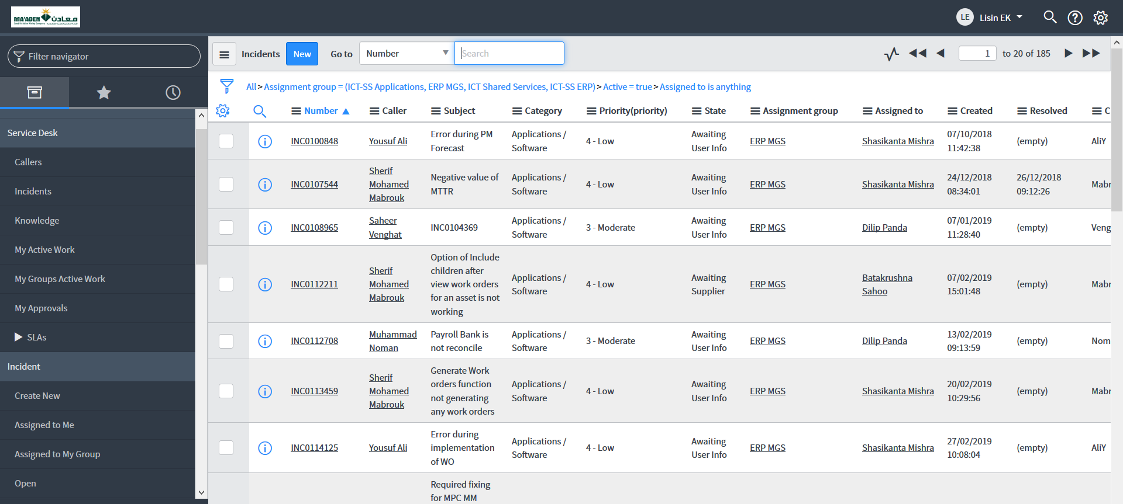

**8.1 Incident Mangement (Ticket Analysis)**

We have analyzed all the repetitive and SEV 1 and SEV 2 Service Now Tickets for the last 1 year with Sibasis Panda (TCS DBA). Please find below the SNOW tickets dump along with the analysis and the action taken by TCS DBA.

